<Title>
<Document Code>

Version <Version>

Class Name
Class Code
Group | Mobile5
Teacher
Project Manager | Mr. Tuan Le
Assign Date
Complete Date
Author
Version
Approved By
Approved Date

Table of Contents

1. Introduction 5
1.1 Purpose 5
1.2 Scope 5
1.3 Definitions, Acronyms and Abbreviations 5
1.4 References 5
2. OVERAL Description 5
2.1 Product Perspective 5
2.2 Product Features 5
2.3 User Documents 5
2.4 Assumptions 5
2.5 Constraints 6
3. Use case model 6
3.1 The Actors 6
3.2 The use cases 6
3.3 Use cases diagram 6
4. Functional Requirements 6
4.1 Feature <Name> 6
4.1.1 Use case <name> _ <ID> 7
4.1.2 Use case <name> _ <ID> (and so on) 7
4.2 Functional Group/Feature <Name> (and so on) 7
5. Non-Functional Requirements 7
5.1 Usability 7
5.2 Reliability 7
5.3 Performance 7
5.4 Supportability 8
5.5 Interface Requirements 8
5.6 Security Requirements 8
5.7 Reports and Form templates Requirements 8
5.7.1 Reports 8
5.7.1.1 <Functional Name 1> Reports 8
5.7.2 Form Templates 9
5.7.2.1 <Functional Name 1> Forms 9
5.8 Other 9
5.8.1 <Feature 1> 9
5.8.2 <Feature 2> 9
6. Conclusion 9

Introduction
Today, the popularity of mobile smartphones with software applications, specially phones use the Android OS. So, we want to develop an application mobile to help user have a better tool to study English.

Purpose
EV-Dictionary runs in Android operation system, using for user to find any words definition, synonyms, antonyms, idioms, pronunciation… A user can use this software with any mobile runs in Android operation system. Helpful, quickly, easy to use are basic requirement of our software.

Scope
EV-Dictionary Software Requirement presents feature of our software. My software develop for android devices (mobiles, tablets run android OS…). We will develop our software can translate some dictionary as English – VietNamese, VietNamese – English and support some popular function.

Definitions, Acronym s and Abbreviations
Term | Definitions, Acronyms and Abbreviations
 | None

References
www.android.developer.com

OVERAL Description

Product Perspective
EV-Dictionary software runs on Android OS version 2.2. This application is developed on Eclipse, ADT plug-in version 12, base on java language.

Product Features
- Lookup
- Pronunciation
- Cross-lookup
- Add new words definition
- Instant search
- History lookup

User Documents
<List the user documentation components (such as user manuals, on-line help, and tutorials) that will be delivered along with the software. Identify any known user documentation delivery formats or standards.>

Assumptions
<List any assumed factors (as opposed to known facts) that could affect the requirements stated in the SRS. These could include third-party or commercial components that you plan to use, issues around the development or operating environment, or constraints. The project could be affected if these assumptions are incorrect, are not shared, or change.>

Constraints
<Describe any items or issues that will limit the options available to the developers. These might include: corporate or regulatory policies; hardware limitations (timing requirements, memory requirements); interfaces to other applications; specific technologies, tools, and databases to be used; parallel operations; language requirements; communications protocols; security considerations; design conventions or programming standards (for example, if the customer’s organization will be responsible for maintaining the delivered software).>

Use case model

The Actors
<List all actors that communicate with the system. And should make a mapping between each feature and actors>
- User

The use cases
System Features | Main Use Case | Use Case ID
 | Manage EV-Dict | UC-01
 | Configure | UC-02
 | Lookup | UC-03
 | Cross-lookup | UC-04
 | Pronunce | UC-05
 | Lookup History | UC-06

Use cases diagram
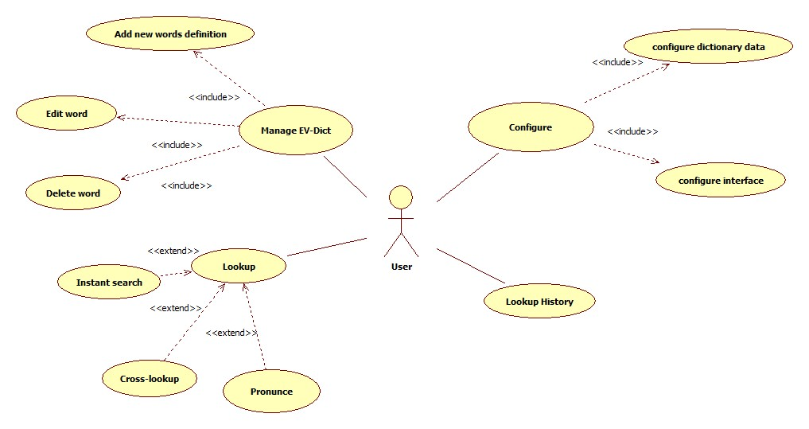

Functional Requirements
<Introduction/description>

Feature Manage EV-Dict
Section/ Requirement ID | Requirement Definition
FR1.1 | Add new words definition
FR1.2 | Edit word
FR1.3 | Delete word

<Manage EV-Dict>_<UC-01>
[Provide a context diagram of the system, with explanations as applicable. The context of a system refers to the connections and relationships between the system and its environment.]
Use Case ID | UC-01
Name | Manage EV-Dict
Goal | The user wants to add/edit/delete a word
Actors | User
Include
Extended | Add new words definition
Pre-conditions | - Application Start  - User uses the function manage ev-dict
Post-conditions | A word was added/edited/deleted success
Main Flow | - User choose the function add or edit or delete  - User input the word to add/edit/delete  - User input the mean of word (with function add/edit)  - User click delete if user wants to delete; or user click save if user wants to add/edit.  - A message show add/edit/delete success or fail
Exceptions
Open Issues

Feature Lookup
Section/ Requirement ID | Requirement Definition
FR2.2 | Cross-lookup
FR2.3 | Pronunce

Use case <Lookup> _ <UC-03>
Use Case ID | UC-03
Name | Lookup
Goal | The user wants to lookup a word
Actors | User
Include
Extended | Instant Lookup, Cross-lookup, Pronounce
Pre-conditions | - Application was started  - User uses the function lookup word
Post-conditions | Return mean of word in Vietnamese
Main Flow | - User chooses the Lookup function  - System shows lookup activity  - User types the word into searching bar  - User clicks the search button  - System searchs in database and return mean of word  - System memorizes this word in to history
Exceptions | - System can’t match the word with database values  - System return null string for user
Open Issues | System can use google translate tool to match word as have exceptions if it have connected to internet

Use case < Cross-loopkup > _ <UC-04>

Use Case ID | UC-04
Name | Cross-loopkup
Goal | Support cross-lookup word
Actors | User
Include
Extended
Pre-conditions | - User uses the function lookup word  - System return mean of word  - User select English word at explain region
Post-conditions | Sytem pronoun the word
Main Flow | - User chooses the Lookup function  - System shows lookup activity  - User types the word into searching bar  - User clicks the search button  - System searchs in database and return mean of word  - User select the word at explain region  - System get that word and show search button  - User click on search button  - System searchs in database and return mean of word  - System memorizes this word in to history
Exceptions | - System can’t match the word with database values  - System return null string for user
Open Issues | System can use google translate tool to match word as have exceptions if it have connected to internet

Use case < Pronounce > _ <UC-05>

Use Case ID | UC-05
Name | Pronounce
Goal | Support pronounce word in searching bar
Actors | User
Include
Extended
Pre-conditions | - User uses the function lookup word  - User types the word into searching bar and click search button  - System returns mean of word
Post-conditions | Pronoun the word in searching bar
Main Flow | - User chooses the Lookup function  - System shows lookup activity  - User types the word into searching bar  - User clicks the search button  - System searchs in database and return mean of word  - User clicks pronoun button  - System searchs pronoun file of word  - System pronoun the word
Exceptions | - System can’t match the word with database values  - System do nothing
Open Issues | System can use google translate tool to pronoun word as have exceptions if it have connected to internet

Feature Lookup
[List the functional requirements for each functional requirements group.]
Exhibit 4 - Sample Requirements Group 1
Section/ Requirement ID | Requirement Definition
FR2.1 | Instant search
FR2.2 | Cross-lookup
FR2.3 | Pronunce

Use case <name> _ <ID>
[Provide a context diagram of the system, with explanations as applicable. The context of a system refers to the connections and relationships between the system and its environment.]
Use Case ID
Name
Goal
Actors
Include
Extended
Pre-conditions
Post-conditions
Main Flow
Exceptions
Open Issues

Functional Group/Feature <Name> (and so on)

Non-Functional Requirements

Usability
[This section should include all of those requirements that affect usability. For example:
- specify the required training time for a normal users and power users to become productive at particular operations

Reliability
[Requirements for reliability of the system should be specified here. Suggestions are as follows:
- Availability – specify percentage of time available (xx.xx%), hours of use, maintenance access, degraded mode operations, and the like.
- Mean Time between Failures (MTBF) – this is usually specified in hours but it could also be specified in terms of days, months or years.
- Mean Time To Repair (MTTR) – how long is the system allowed to be out of operation after it has failed?
- Accuracy – specify precision (resolution) and accuracy (by some known standard) that is required in the systems output.
- Maximum bugs or defect rate – usually expressed in terms of bugs/KLOC (thousands of lines of code), or bugs/function-point.
- Bugs or defect rate – categorized in terms of minor, significant, and critical bugs: the requirement(s) must define what is meant by a “critical” bug; for example, complete loss of data or complete inability to use certain parts of the functionality of the system.]

Performance
[The performance characteristics of the system should be outlined in this section. Include specific response times. Where applicable, reference related Use Cases by name.
- Response time for a transaction(average, maximum)
- Throughput (for example, transactions per second)
- Capacity (for example, the number of customers or transactions the system can accommodate)
- Degradation modes (what is the acceptable mode of operation when the system has been degraded in some manner)
- Efficient use of resources: memory, disk, communications, and so forth]

Supportability
[This section indicates any requirements that will enhance the supportability or maintainability of the system being built, including coding standards, naming conventions, class libraries, maintenance access, maintenance utilities. In other words, these requirements ensure that the software can be easily modified to accommodate enhancements and repairs. The scope of this section extends over:
- testability
- extensibility
- adaptability
- maintainability
- configurability
- serviceability
- install ability
- localizability
- portability
- compatibility
- design constraints
- Testability requirements.]

Interface Requirements
<Introduction/description>
No. | Interface Process Name | Import / Export | Functional Affected | Purpose | Frequency

Security Requirements
<Introduction/description>

Reports and Form templates Requirements
<Introduction/description>

Reports
<Introduction/description>

<Functional Name 1> Reports

No. | Report Name | Usage | Description | Input Parameter(s) | Frequency

Form Templates
<Introduction/description>

<Functional Name 1> Forms
No. | Form Name | Usage | Description

Other
<Introduction/description>

<Feature 1>

<Feature 2>

Conclusion

---------- End of Document ----------

